Board Members Present:
Heather Sharar | Ambulance Assoc. of PA
Don DeReamus | Ambulance Assoc. of PA
Tim Hinchcliff | Burholme Ambulance Corps
Kent Knable | Centre LifeLink EMS
Harry Moore | Chester Co Dept of Emergency Svcs
Mehmet Barzev | City of Allentown EMS
Matt Brett | City of Allentown EMS
Barry Albertson | Community LifeTeam
Chris Chamberlain | Hosp and Healthcare Assoc of PA
Tony Deaven | Lower Allen EMS
Juliet Altenburg | PA Trauma Systems Foundation
David Jones | Penn State University
Anthony Martin | Tower Health Direct
Dr. Ron Roth | UPMC Presbyterian
J.R. Henry | Valley Ambulance Authority
Dr. Steve Schirk | Wellspan York Hospital
Anthony Tucci | Western Berks Ambulance

Council Members Present:
Krista Brands | American Trauma Society - PA Division
Bill Wells | Brandywine Tech College High School
Larry Loose | Bucks Co EMS Council
Michele Rymdeika | Bucks Co EMS Council
Mark Giangiulio | Delaware Co EMS Council
Annie Phillips | Delaware Co EMS Council
Dr. Duane Siberski | Eastern PA EMS Council
Jason Smith | Eastern PA EMS Council
John Kloss | Eastern PA EMS Council
Matthew Welch | Elverson Honeybrook EMS
KayElla Bleecher | Emergency Nurses Assoc
Thomas McElree | EMS West EMS Council
Brian Shaw | EMS West EMS Council
Joe Stevens | First Capital EMS
Bob Stakem | Hbg. Area Comm College
Mervin Wertz | Lower Alsace EMS
Dr. Jeff Myers | LTS EMS Council
William Miller | LTS EMS Council
Chris Dell | McCandles-Franklin Park EMS
Dr. Alvin Wang | Montgomery Co EMS Office
Steve Bailey | Non Profit Emerg Svcs Beaver Co
Rich Kelley | Mt. Nittany Medical Center EMS
Dr. Bryan Wexler | PA College of Emergency Physicians
Jerome Ozog | PA Fire And Emerg Svcs Institute
Keith McMinn | Penn State LifeLion Hershey
Bob Hotchkiss | Southern Chester Co EMS
Dr. Jeff Kuklinski | St Lukes Health Network
Tony Bixby | Susquehanna Regional EMS
Mark Trueman | Susquehanna Regional EMS
Jim Slotterback | Susquehanna Regional EMS
Jean Bail | Thomas Jefferson University
Myron Rickens | UPMC
Dr. Greg Hellier | PA College of Emergency Physicians
Dr. Greg Frailey | UPMC Williamsport

Bureau of EMS Staff Present:
Sunny Podolak, Acting Director
John Englert
Jay Taylor
Jenni Hoffman

PEHSC Staff Present:
Janette Swade
Butch Potter
Andy Snavely
Duane Spencer

Call To Order |  | The meeting was called to order at 1000 hours by President Dave Jones
Approval of Minutes | The minutes from the March 15, 2023, meeting was reviewed. | MOTION: TONY TUCCI  SECOND: ANTHONY MARTIN  TO APPROVE THE MINUTES AS DRAFTED.  RESULT: MOTION CARRIED
President’s Report | President Dave Jones reported the following:  - Passing of Paramedic Jay Miles from Upper Perkiomen EMS, LODD, March 13, 2023  - Bylaws changes from last meeting; there may be additional changes due to changes in state law.  - Testimony to legislature on system issues during EMS week  - System concerns: we have been in conversation with AAP and PFESI. Joint letter to Senator Michelle Brooks expressing key concerns impacting sustainability.  - This is the last meeting of the current BOD and the first meeting of the incoming BOD.  - Thanks to outgoing board members due to term limits (CEM, Cumberland Goodwill, Non-Profit EMS Org of Beaver County)  - Welcome to the oncoming board members elected at the annual meeting.
Treasurer’s Report | Dr. Ron Roth presented the current treasurer’s report (attached). | MOTION: TONY TUCCI  SECOND: BARRY ALBERTSON  APPROVE THE TREASURER’S REPORT AS PRESENTED.  RESULT: MOTION CARRIED

Executive Director’s Report | Executive Director Janette Swade reported the following:  - IRS Form 990 complete and included in today’s meeting materials. Has been submitted to the IRS.  - Secondary income account is for the most part depleted due to cash flow issues.  - We have received a new EMSOF contract extension from the DOH, but no funding increase. This continues to be a challenge and currently the office is down to 3 staff, which includes the Director, but not the EMSC Manager, who is dedicated to the EMSC project.  - New EMSC grant received from federal government, now processing through the DOH. Contract funding was increased.  - FY 23-24 BOD will need to complete a Conflict-of-Interest Statement.  - Community Paramedicine legislation is moving in the House again. Have asked the CP Task Force for comment. Also legislation on MA loaded mileage and naloxone related issues.  - Opportunities Workgroup issues to be discussed within other committees and task forces.  - Issues pending with the BEMS on previous initiatives and recommendations. We will be following up with the Department.
Department of Health Report | The Council welcomes Acting BEMS Director Sunny Podolak, who shared the following:  - Has 22 years with the DOH, including Community Health System. Has worked as an executive assistant with the Dep. Sec. responsible for BEMS.

Medical Advisory Committee Report | Dr. Alvin Wang, Co-Chair, reported the following:  - The MAC continues to work with the Bureau of EMS on the 2023 statewide protocol update. With the change in clinical leadership at the BEMS, the timeline for completion has been extended to late summer.  - The committee expressed grave concerns for the proposed statement in BLS Protocol 201 regarding patient abandonment. The members are unanimous in their opposition to this statement and feel it has no place in a clinical protocol and could cause increased liability exposure for providers and agencies.  - An algorithm was added to Protocol 201 to provide a visual pathway for providers to determine an acceptable patient disposition with appropriate documentation.  - Dr. Frank Guyette presented a DOD funded research project to study ketamine v. fentanyl for pain control in trauma patients with compensated shock. Recommended study to the BEMS.  - Joe Ponko, on behalf of Dr. Rick Wadas, presented a proposed pilot program in the EMS West region for the use of nitrous oxide/oxygen mixture (N2O) by BLS for musculoskeletal pain control. N2O has been on the approved med list for ALS providers since the 1980’s. The MAC voted to recommend the pilot to the BEMS.  - Dr. Crawford Mechem requested the MAC’s support for the community distribution of test strips for substances of abuse by EMS. The committee voted to support this initiative and VTR# 0423-01 was approved by the executive committee.  - Dr. Wang proposed a pilot program in which patients in cardiac arrest, primarily in Montgomery County, with a specific set of circumstances, would be transported to a hospital with EMCO capability instead of the closest facility.  In a selected patient population, ECPR has shown an increase in survival to discharge from 7% using traditional ACLS to 34% with the addition of ECPR. The MAC voted to recommend the pilot to the BEMS.  Chris Chamberland followed up on abandonment issue. Does the board have an opportunity to make a formal recommendation to remove any references to abandonment. Sunny Podolak commented that those references are being removed. | MOTION: CHRIS CHAMBERLAND  SECOND: TONY DEAVEN  RECOMMEND TO THE DEPARTMENT TO REMOVE REFERENCES TO PATIENT ABANDONMENT IN BLS PROTOCOL #2O1.  RESULT: MOTION CARRIED
Critical Care Task Force Report | Dr. Greg Frailey, Chair, reported the following:  - This was a very productive meeting that focused on two areas:  - Proposed changes or additions to the statewide CCT protocols and;  - Improved utilization of existing CCT resources, particularly the critical care trained paramedic.  - The workgroup felt that additional protocols, except one that had been previously submitted to the BEMS, were not needed at this point. Instead, they elected to focus on resource utilization.  - Are there additional medications and/or monitoring of other therapies that can be shifted to the ALS level for the stable patient? Conceptually discussed chest tube monitoring, Cardene infusions and blood products etc.  - Much of the meeting focused on a different way to determine the crew resources needed for transport.  - Currently patients are stratified based on infusing medications and ongoing therapies, e.g., patient is on XYZ infusion, therefore every patient with this drug infusing needs a PHRN, irrespective of their overall acuity.  - We are now exploring the concept of crew resources based on the patient’s overall acuity, stratified into “stable” or “unstable” using a standard definition and physician assessment.  - There will be common sense exceptions to the rule, e.g., balloon pumps, ECMO, neonates, etc.  - Patients who are stable, would be monitored by a CCT trained paramedic, with an ALS paramedic is support. Conversely, unstable patients would still get a multidisciplinary teams that includes a PHRN or higher.  - In future work sessions, the group will apply this new principle to the current CCT scope of practice document and approved medication list to determine if is a workable alternative.  - Whatever the final outcome, this workgroup, with its diverse composition, is committed to deliver recommendations that provide reasonable patient safety and improve the timeliness of patient transport to a higher level of care.  - In providing reasonable patient safety, the group will explore risk v. benefit, while managing the always present “what if…” scenario that can prevent the system from evolving.  - A question was asked, can a licensed CCT agency link up a CCT provider to a licensed ALS agency to make up a ground critical care transport ambulance? A similar question at the ALS/BLS level has been asked of the BEMS.

RSI Task Force Report | Dr. Greg Frailey, Chair, reported the following:  After 2 years of work, involving hundreds of hours by a dedicated group of healthcare professionals, we are pleased to deliver our recommendations for a statewide pilot for Ground ALS Use of Drug Assisted Airway Management, a.k.a RSI.  These recommendations and proposed pilot program have been reviewed and endorsed by both the PEHSC MAC and Critical Care Transport Task Force and are presented to the Board in the form of VTR# 0623-01.  Questions regarding the use of Sux vs. Rocuronium as the first line neuromuscular blocking agent. Both agents are available in the protocol – Rocuronium is available first line via medical command order. | MOTION: JR HENRY  SECOND: DR. JEFF MYERS  TO ACCEPT VTR 0623-01, RECOMMENDATIONS FOR THE STATEWIDE RSI PILOT PROJECT  RESULT: MOTION CARRIED
Special Operations Task Force Report | Dr. Duane Siberski, Chair, reported the following:  - A tactical EMS course sponsor should be accredited by the Pennsylvania Department of Health as an advanced life support education institution, licensed tactical EMS agency or a nationally recognized organization with expertise in tactical EMS to conduct a tactical paramedic course.  - As part of its approval process the Department may require the course sponsor to submit course objectives, content outline, instructional guidelines or other information as may be needed in order for the Department, or its designee, to determine if the proposed course meets the educational standards outlined in this document.  - ESOP: The tactical paramedic will only be permitted to use the approved expanded scope of practice when providing care for a licensed tactical EMS agency, or in other patient settings authorized by the Department of Health.  - Reciprocity: Should providers posses training, including prior military experience, that is not currently approved, they may submit detailed documentation of such training to the Department for consideration.  - Agency Medical Director: Current Agency Medical Director requirements – current law  - Have successfully completed and maintain certification as a Pre-Hospital Physician as recognized by the Department.  - Have completed an EMS agency medical director course, an EMS fellowship, or other EMS training program determined by the Department to be equivalent.  - Be an active medical command physician and has successfully completed the medical command course as recognized by the Department and serves or served as an ALS agency medical director having completed an EMS agency medical director course as recognized by the Department.  - Next Phase: Recommend this part of the project to the Department in accordance with 28 Pa Code § 1027.41(c)  - Develop Tactical Paramedicine protocols  - Develop Tactical EMS Agency Licensure requirements | MOTION: BARRY ALBERTSON  SECOND: MERV WERTZ  ACCEPT VTR 0623-02,  RECOMMENDATIONS FOR IMPLEMENTING TACTICAL EMS  RESULT: MOTION CARRIED

EMS Education Task Force Report | Mervin Wertz, Chair, reported the following:  - Position Paper for Consideration: Continued Use of the NREMT Cognitive Testing Process in Pennsylvania  - PEHSC supports the continued use of the National Registry of EMTs computer-adaptive testing process  - It is important for Pennsylvania to provide a national-level test for providers at all levels  - Test questions are developed and validated based on the NHTSA education guidelines  - NREMT testing is required as a condition of the EMS COMPACT, of which Pennsylvania is now a member  - 48 other states continue to use the NREMT testing process  Bill Wells commented on cost issues related to testing. Tony Deaven suggested using fireworks money to pay for the NREMT exam.  Dr. Roth commented that he does not want to see education “dumbed down.” We need to strengthen instruction in order to be more successful. | MOTION: Dr. JEFF MYERS  SECOND: TONY DEAVEN  TO ACCEPT THE POSITION STATEMENT ON CONTINUED USE OF NREMT TESTING.  RESULT: MOTION CARRIED
EMS for Children Project Report | Duane Spencer, Project Manager, reported the following:  The committee met on June 20, 2023.  The 2023-2027 EMSC Grant Award contract has been approved. The identified priorities going forward are:  - Facility Readiness and Recognition Program  - EMS Agency Recognition Program  - Family Advocacy Network growth  - The 2023-2024 EMSC EMS Survey is in progress  - New/Upgraded Pediatric Voluntary Recognition Program (PVRP) in 2022-2023 (67). Total PVRP agencies (253)  New Pediatric Emergency Care Coordinators (PECC) in 2022-2023 (97). Total PECCs (311)
EMS Operations Committee Report | Tony Deaven, Chair, reported the following:  The committee met on May 1, 2023.  - Concept for Consideration 0622-01, “Shared Staffing Operations…” Still awaiting a response from the BEMS.  - Since the establishment of the EMSVO provider certification by Act 37 of 2009, what if any impact has this initiative has on reducing EMS vehicle crashes? How many providers have had their EMSVO certification suspended or revoked by the BEMS since 2013?  - Discussed the permanency of the relaxed BLS minimum staffing standards.  - Discussed the prevalence of QRS usage and the impact of DOH licensure on QRS agencies, especially those associated with volunteer fire agencies.
PA EMS Awards | Duane Spencer reported the following:  Award winner list attached. Delivered during EMS Week – very well received by recipients. Poster presentation in Capitol rotunda during EMS Week.
PA EMS Conference | Andy Snavely reported the following:  The conference will occur on Sept 5-8, 2023.  - Registration is open and attendee #s are building.  - There are 25 sessions this year and the cost to attend is entire conference is $10.00. This small fee is necessary to ensure the event breaks even financially.  - Sponsors include: Penn Medicine Lancaster General Health, Wellspan Health, Glick EMS, Penn State Health and TOWER Direct.
Membership Committee | The committee vetted the affiliate membership application of Mr. James Walls. | MOTION: TONY DEAVEN  SECOND: MERV WERTZ  TO ACCEPT MR. JAMES WALLS FOR AFFILIATE MEMBERSHIP.  RESULT: MOTION CARRIED
Nominating Committee | The nominating committee presented the slate of candidates for the FY 23-24 Executive Committee.  President – Dave Jones, Penn State University  Vice President – Tony Deaven, Lower Allen EMS  Secretary – Chris Chamberlain, Hosp. & Health System Assoc of PA  Treasurer – Dr. Ronald Roth, UPMC Presbyterian  Member At Large – Anthony Martin, TOWER Direct  Member At Large – Kim Holman, Good Fellowship Ambulance and EMS Training  The current EC members are eligible to serve and have indicated their desire to continue to service another year.
Adjourn the FY 22-23 Board of Directors Meeting |  | MOTION: TONY DEAVEN  SECOND: CHRIS CHAMBERLAIN  RESULT: MOTION CARRIED

Convene the FY 23-24 Board of Directors Meeting |  | The meeting was called to order by President Dave Jones
FY 23-24 Executive Committee Elections | Slate of candidates for the executive committee was presented for the board’s consideration.  President – Dave Jones, Penn State University  Vice President – Tony Deaven, Lower Allen EMS  Secretary – Chris Chamberlain, Hosp. & Health System Assoc of PA  Treasurer – Dr. Ronald Roth, UPMC Presbyterian  Member At Large – Anthony Martin, TOWER Direct  Member At Large – Kim Holman, Good Fellowship Ambulance and EMS Training  Asked for nominations from the floor – none. | MOTION: TONY DEAVEN  SECOND: DON DEREAMUS  TO ACCEPT THE SLATE OF CANDIDATES FOR THE FY 23-24 EXECUTIVE COMMITEE AS REPORTED.  RESULT: MOTION CARRIED
Organizational Reports | AAP:  - HB 479, loaded MA mileage passed house. Similar bill in senate but after 5 miles.  - HB 130, Community Paramedicine, AAP came out against the bill due to potential impact to existing programs. Wants to work with stakeholders to develop better language.  - PTSD legislative development  - HB 1500 passes House to increase $15 minimum wage. There is concern for rural EMS ability to pay – need better reimbursement.  - Testified before the Senate Health Committee on EMS system issues  - On July 6th there will be a workforce meeting with various stakeholders.  - PA EMS Bike Ride September 9-11  - Annual Stars of Life dinner on September 11th in Grantville.  PFESI:  - In step with other stakeholders on various EMS issues  - EMS Management course completed.  PTSF:  - Upcoming board meetings.  - Potential to add several trauma centers this year.  PACEP:  - Meeting with Active EMS Director Podolak on the role of the EMS agency medical director in the delivery of quality EMS care
Adjourn the FY 23-24 Board of Directors Meeting |  | MOTION: TONY TUCCI  SECOND: MATT BRETT  RESULT: MOTION CARRIED.

TREASURER’S REPORT
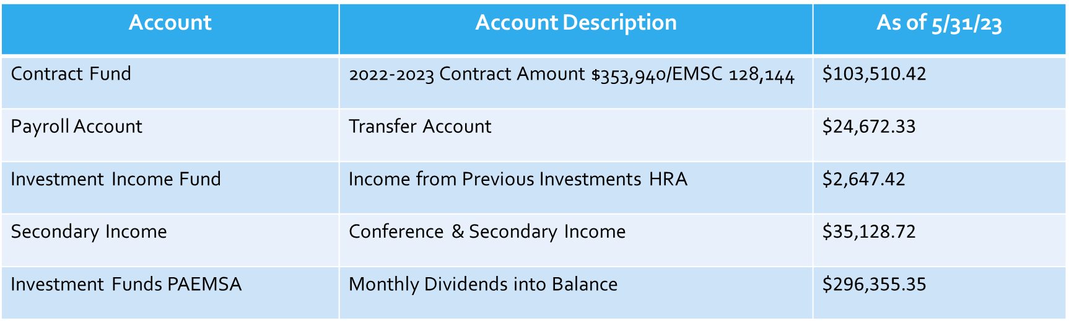

2023 PA EMS AWARD RECIPTIENTS
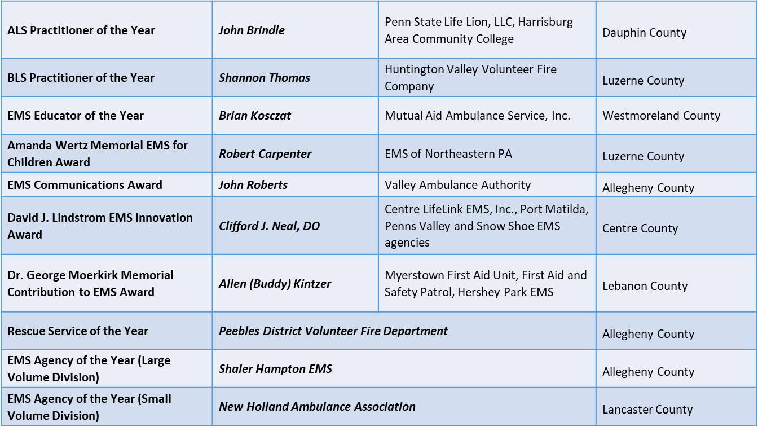

2023 PA EMS AWARD RECIPIENT GEOGRAPHIC DISTRIBUTION
