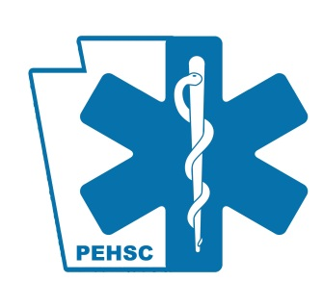
Medical Advisory Committee
“Your Voice In EMS”

Meeting Agenda
Wednesday, January 20, 2021
- Call to order
- Approval of November 11, 2020 meeting minutes
- Reports
  - DOH
  - PTSF
  - EMSC
  - PEHSC
- New Business
- 2021 PA Statewide Protocol Review – Dr. Kupas
- Other Business
  - Next regular meeting date: Wednesday April 14, 2021 @1000 hours
- Adjournment

